**Library Management System**



**Aiperi Osmonaalieva COM-18**

**What you need to do this Project?** You need XAMPP Control Panel, MySQL , Sublime Text to code PHP HTML & CSS or Visual Code studio you can use any IDE that you want.

Firstly

You must write or imagine how your web page will look like, how many Pages there will be and create that files and connect them

I have many pages on my site, but they contain a minimum of information. The main pages are the admin and student pages, the student can register himself and create himself a password and ID number.

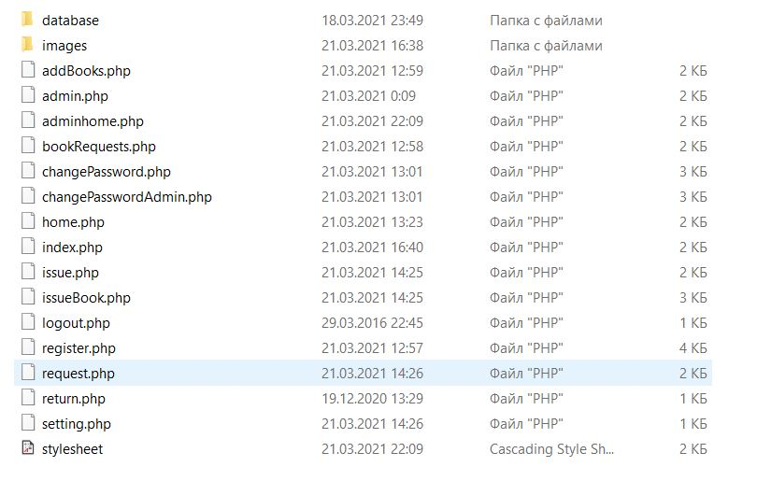



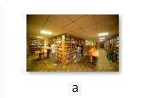

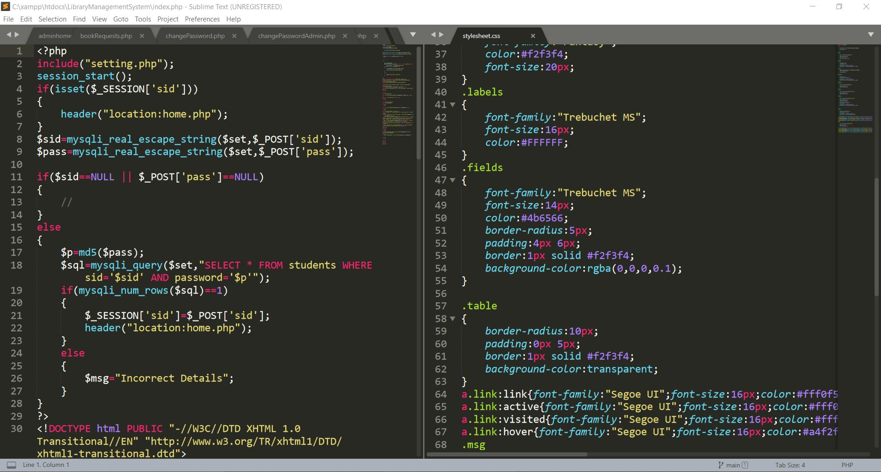

**SQL Files**

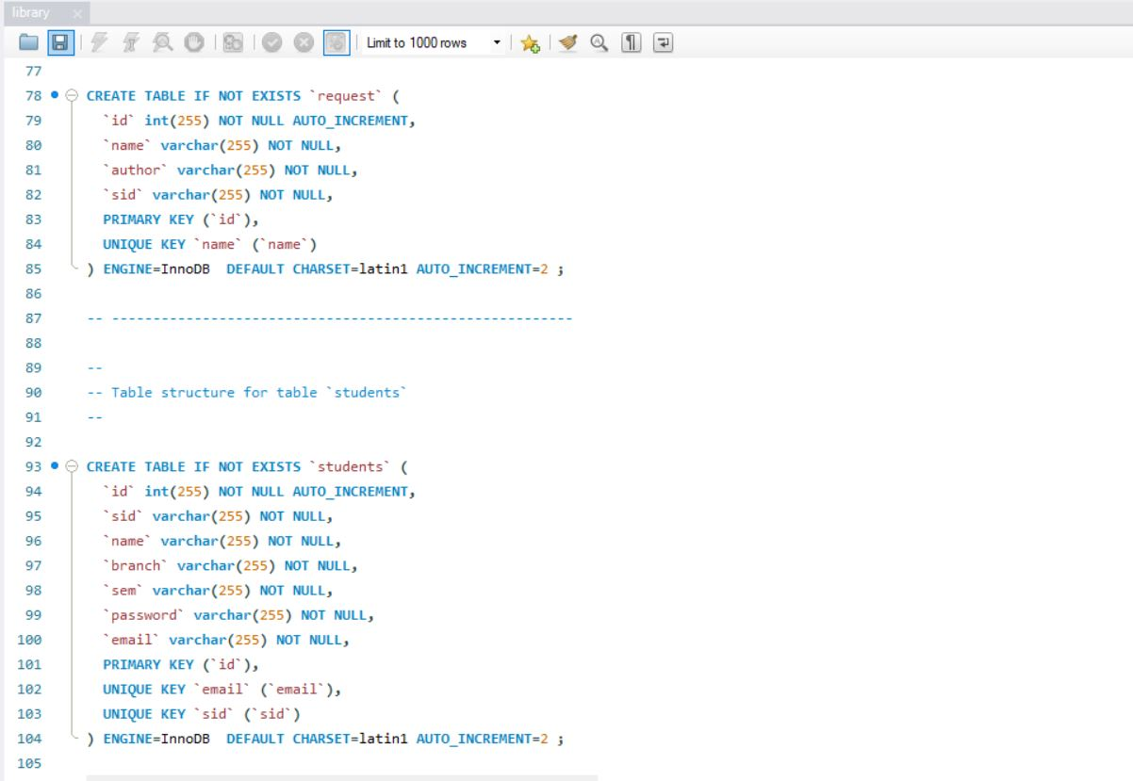

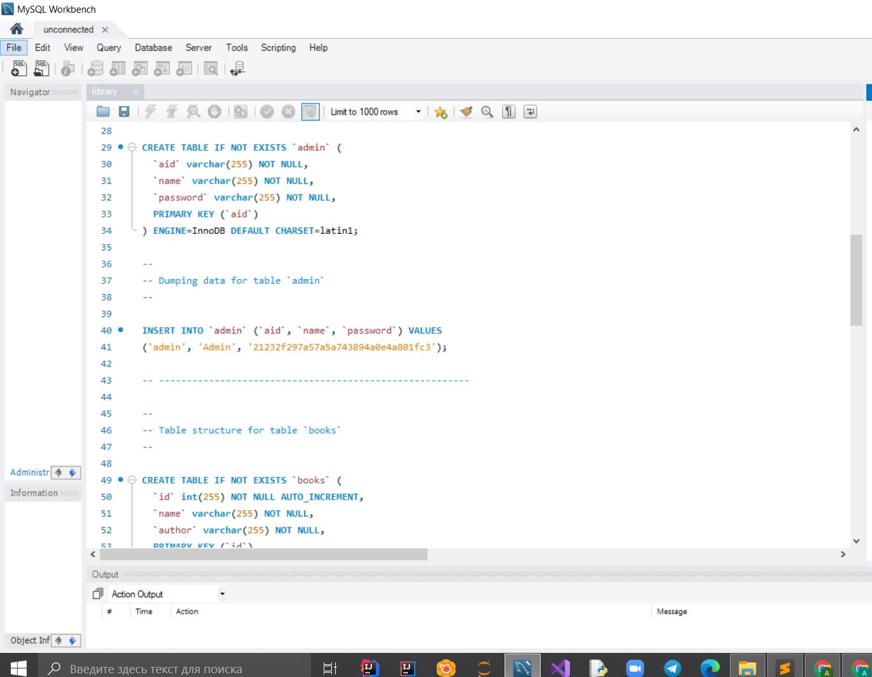

**SQL Files on XAMPP**

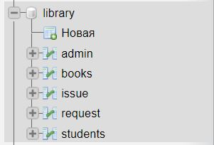

**Connecting to SQL**

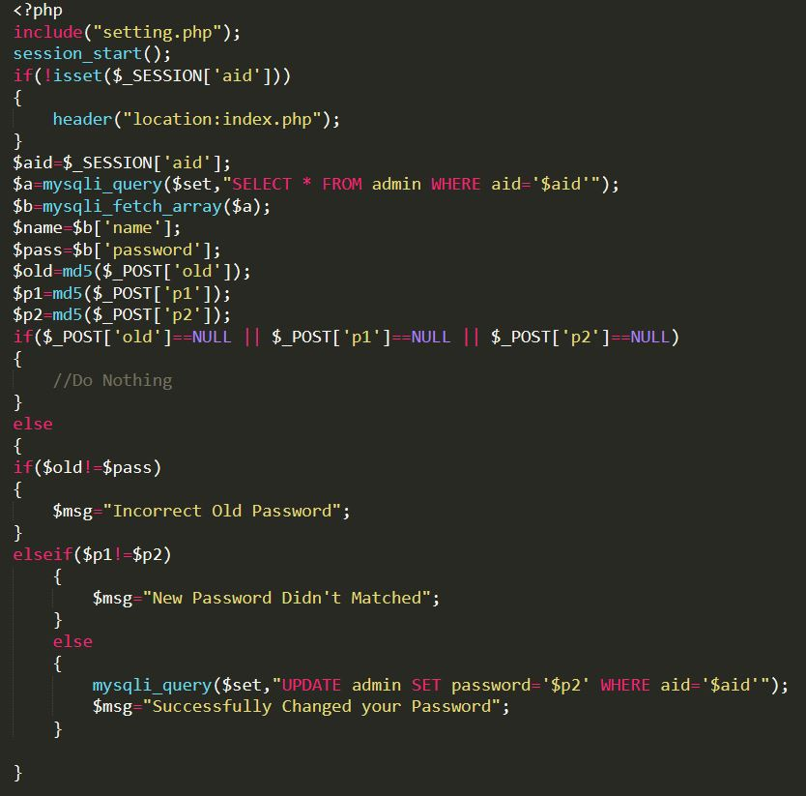

**Connect to css file**



**SQL File on XAMPP**

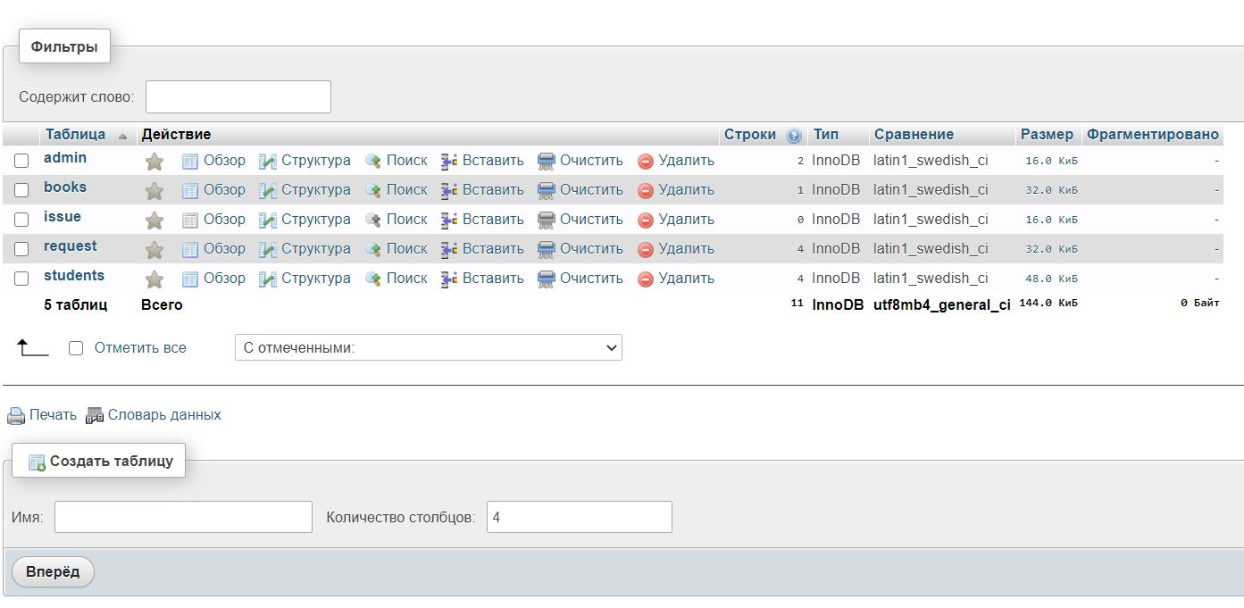

**Every page of the site is the same just has a little difference as an example you can look to this sign in page**

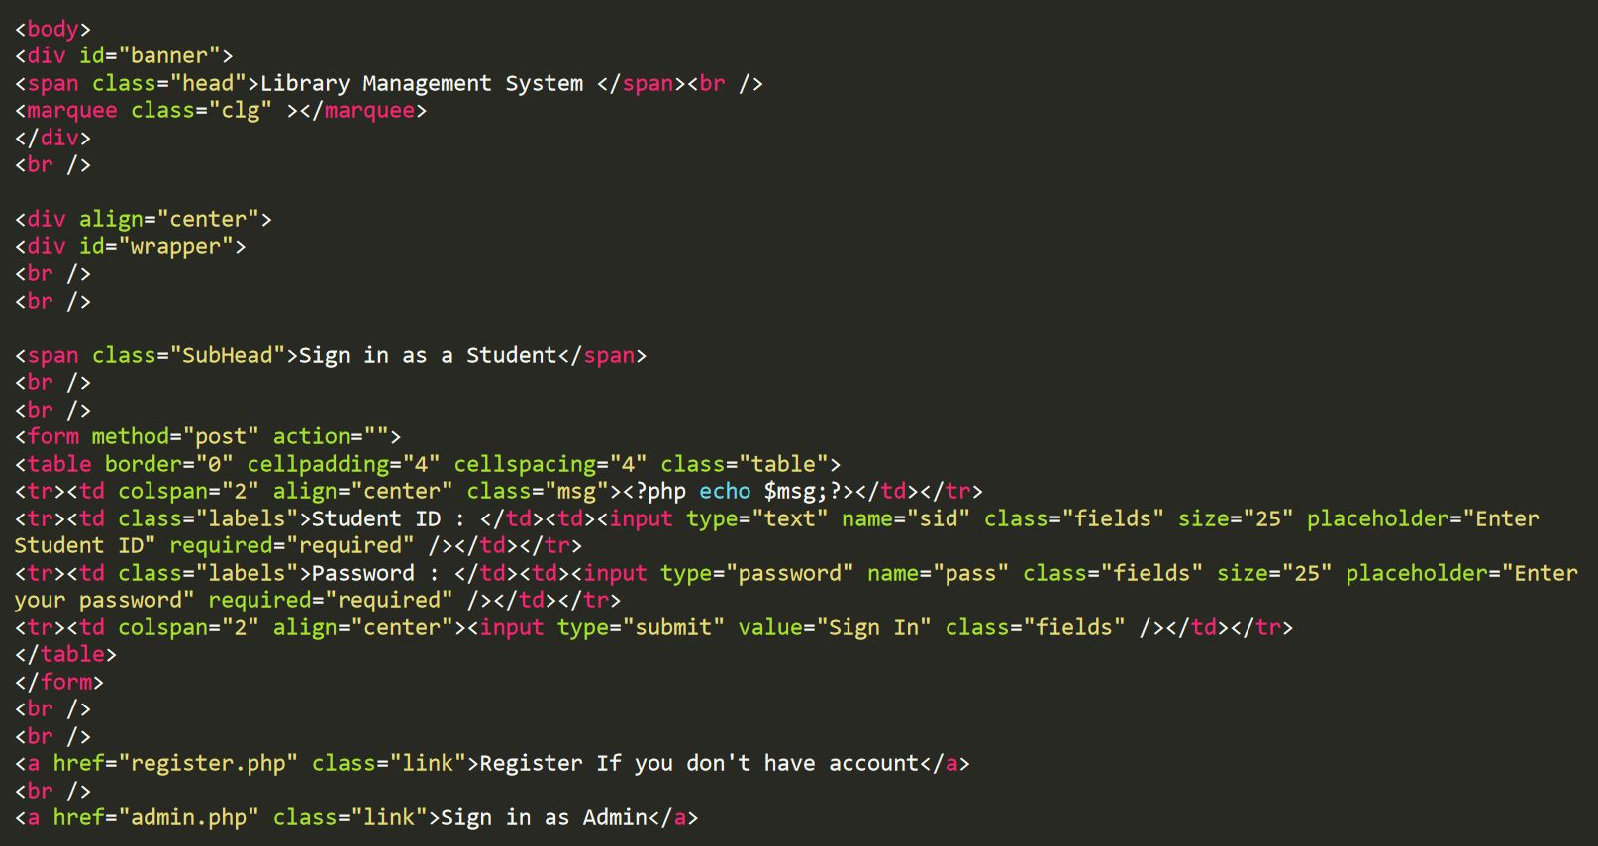

**There is a link to my github you can clone it and learn: https://github.com/Aiperi233/webprojectiau**